**FRRN-b Model**

**Accuracy:**

Overall Accuracy: 0.5977

**Accuracy, Precision & Recall:**

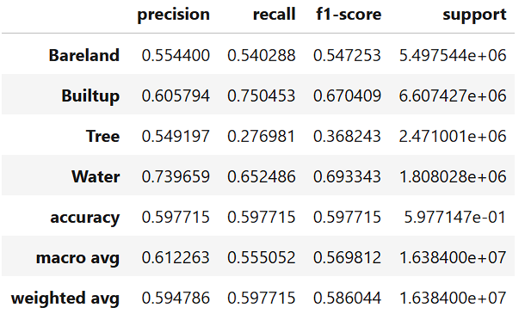

**IoU:**

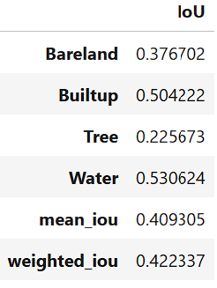

**Model Complexity Stats:**

=== Model Complexity ===

Total Parameters: 0.30M

Trainable Parameters: 0.30M

=== Model Performance Statistics ===

FLOPS: 4.27 GFLOPs

Speed: 19.63 FPS

**Train-Val Loss v/s epochs:**

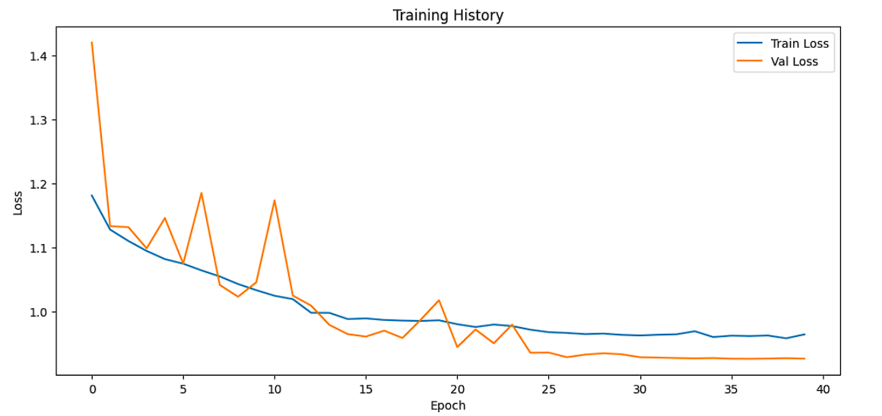

**Confusion Matrix:**

